Software Architecture and Design Specification
Project: Survey Management System (SMS)
Version | 1.0
Authors | Harshit Vaish, Nakka Gopya, Bhavya K, Devika N
Date | 21-10-2026
Status | Draft
Methodology | Agile (Scrum)
Architecture | Layered (3-tier) client-server modular monolith, REST API

Revision History
Version | Date | Author | Change Summary
1.0 | 21-10-2026 | SMS Team | Initial architecture and design specification

Approvals
Role | Name | Signature / Date
Course Coordinator
Dev Lead
Product Owner

1. Introduction

1.1 Purpose
This document specifies the architecture and design of the Survey Management System (SMS) v1.0, a web application for creating well-defined online surveys, helping people take them, and consolidating and publishing the results. It records the architectural decisions, the structure of the system, and the detailed design of its main flows, interfaces and data, so that the team can build, test and maintain the system consistently.

1.2 Scope
The architecture covers the capabilities defined in the SMS SRS v1.0:
- User authentication, password reset and role-based access (Creator, Respondent, Administrator).
- Survey creation and management: five question types, mandatory/optional questions, editing in draft, and the Draft / Published / Closed lifecycle.
- Publishing and sharing through a shareable link and QR code.
- Survey taking with validation, duplicate-submission prevention and anonymous responses.
- Result consolidation, charts, and CSV/PDF export.
- Cross-cutting security, performance, availability and maintainability requirements.
Out of scope for v1.0: conditional questions, partial-progress saving, and email invitations. Third-party hosting and the internals of the SMTP and CAPTCHA providers are treated as external systems.

1.3 Audience
Developers, QA engineers (the test plan traces to this design), security reviewers, instructors/evaluators, and future maintainers.

1.4 Definitions
Term | Meaning
SMS | Survey Management System
SRS / SAD / STP / RTM | Software Requirements Specification / Software Architecture and Design Specification / Software Test Plan / Requirements Traceability Matrix
SPA | Single Page Application
REST | Representational State Transfer, HTTP/JSON API style
JWT | JSON Web Token used for stateless authentication
RBAC | Role-Based Access Control
ORM | Object-Relational Mapper
ADR | Architecture Decision Record
TLS | Transport Layer Security
STRIDE | Spoofing, Tampering, Repudiation, Information disclosure, Denial of service, Elevation of privilege
CAPTCHA | Test used to distinguish humans from bots

2. Document Overview

2.1 How to use this document
Section 3 explains the architecture (goals, stakeholders, component view, pattern choice with alternatives, technology, risks, traceability, security). Section 4 gives the detailed design: survey lifecycle, sequence diagrams, API contracts, error handling, and UX design. Section 5 holds appendices. Key decisions are recorded as ADRs in Section 3.5.

2.2 Related Documents
Document | Relationship
SMS SRS v1.0 | Source of requirement IDs (SVY-F, SVY-NF, SVY-SR) used for traceability
SMS Test Plan v1.0 | Verifies this design; test cases TC-* trace to the components defined here
RTM | Maps requirement to module to test case

3. Architecture

3.1 Goals and Constraints

Architectural goals
- Correctness and integrity: no lost or duplicated responses; consistent aggregate results.
- Performance: 95% of requests within 2 s; 500 concurrent respondents (SVY-NF-001, 002).
- Availability: 99.5% monthly (SVY-NF-003).
- Security: TLS 1.2+, hashed passwords, server-side authorisation, injection protection, rate limiting (SVY-SR-001 to 005).
- Usability and reach: responsive UI on desktop and mobile, all major browsers (SVY-NF-004).
- Maintainability and testability: at least 80% coverage enforced in CI (SVY-NF-005); modular code that a four-person team can own.

Constraints
- Student team of four, Agile sprints, limited time (Sprint 0 to Sprint 4).
- Free-tier / low-cost cloud hosting (noted as a risk in the test plan).
- Must integrate with an external SMTP provider and CAPTCHA service.
- Must follow OWASP Top 10 and WCAG 2.1 guidance.
- Anonymous responses must not store any user identifier (SVY-F-012).

3.2 Stakeholders and Concerns
Stakeholder | Concerns | Addressed by
Survey Creator | Easy builder, reliable publishing, correct results and export | Survey, Publishing, Results, Export services; lifecycle state machine
Respondent | Fast, mobile-friendly form; privacy; no accidental duplicates | Responsive SPA; anonymous design; submission guard
Administrator | User and survey oversight, access control | RBAC in API gateway layer; Auth Service
Developers | Modularity, clear boundaries, quick onboarding | Layered modules with explicit interfaces
QA / Test team | Testability, coverage, mocks for email | Dependency injection; Mailpit; Repository abstraction
Security reviewers / Regulators | Data protection, threat mitigation | Section 3.9 security architecture
Course evaluators | Traceable, justified design | Sections 3.5 and 3.8

3.3 Component (UML) Diagram
Figure 1 shows the main components, their provided/required interfaces and dependencies. Solid arrows are the main call direction; dashed arrows are usage dependencies between services or on external systems.
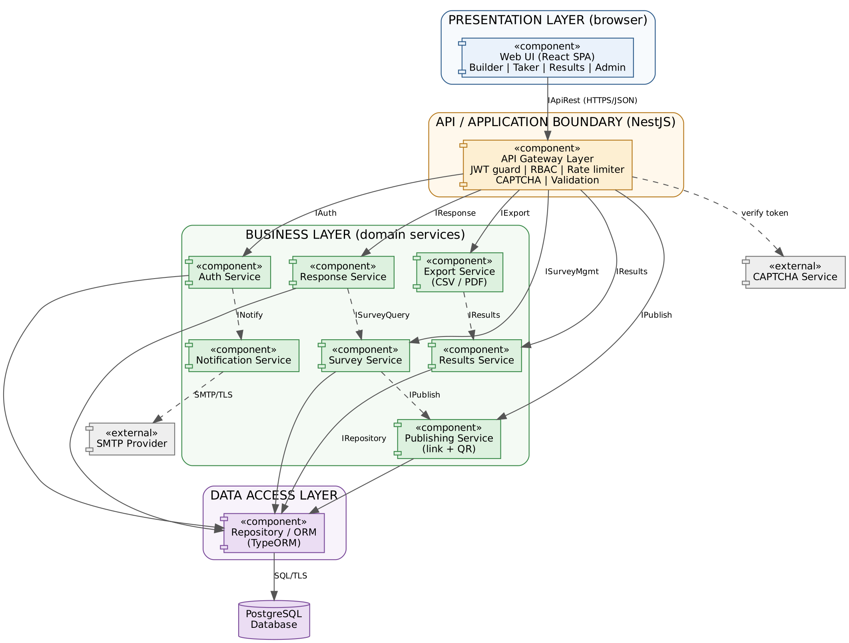
Figure 1: SMS component diagram (layered architecture)

3.4 Component Descriptions
Component | Responsibility | Interfaces
Web UI (React SPA) | Survey builder, survey-taking form, results dashboard with charts, admin screens, login/registration. Responsive layout 360 to 1920 px. | Requires IApiRest
API Gateway Layer | Single entry point. TLS-terminated requests; JWT authentication; RBAC and ownership checks on every endpoint; rate limiting (HTTP 429); CAPTCHA verification; input validation and sanitisation; uniform error format. | Provides IApiRest; requires all service interfaces
Auth Service | Registration, login, password hashing (Argon2), token issue, password-reset tokens (single use, 30 min expiry), role management. | Provides IAuth; requires IRepository, INotify
Survey Service | Create/edit/delete surveys and questions, question types, mandatory flags, ordering, lifecycle transitions, structure lock after publish. | Provides ISurveyMgmt, ISurveyQuery; requires IRepository, IPublish
Publishing Service | Generates unique slug-based shareable link and QR code image; resolves slug to survey. | Provides IPublish; requires IRepository
Response Service | Validates and stores submissions; enforces mandatory fields, open/close state, duplicate prevention through submission guard; keeps anonymous responses unlinked. | Provides IResponse; requires ISurveyQuery, IRepository
Results Service | Consolidates responses: counts, percentages, averages, text answers; returns data for charts. | Provides IResults; requires IRepository
Export Service | Builds CSV and PDF reports from consolidated results; owner-only. | Provides IExport; requires IResults
Notification Service | Sends emails (password reset) through SMTP; isolates the provider so it can be swapped or faked in tests. | Provides INotify; requires SMTP
Repository / ORM | Data access, transactions, parameterised queries only. | Provides IRepository; requires SQL
PostgreSQL | Relational store for users, surveys, questions, responses, guards, reset tokens. | SQL over TLS
SMTP / CAPTCHA (external) | Email delivery and bot protection. | SMTP/TLS, HTTPS

3.5 Chosen Architecture Pattern and Rationale
Layered (3-tier) client-server architecture, implemented as a modular monolith. A React single-page application (presentation tier) talks over HTTPS/REST to one NestJS application server (business tier) made of independent domain modules (Auth, Survey, Publishing, Response, Results, Export, Notification) behind a gateway layer. A repository layer isolates the single PostgreSQL database (data tier). Modules interact only through their declared interfaces, so any of them can later be extracted into a separate service if load demands it.
Criterion | Layered modular monolith (chosen) | Microservices | Plain client-server (single tier, no layering)
Fit to scope | Good: seven well-bounded modules, one team | Over-engineered for a four-person team | Fits, but logic mixes with UI/data code
Performance (2 s, 500 users) | Met by stateless horizontal scaling and indexed SQL | Meets, but adds network hops per request | Meets, hard to tune
Data consistency | Single ACID database; duplicate guard and response insert in one transaction | Distributed data; needs sagas/eventual consistency | Single DB, consistent
Security | One enforcement point (gateway layer) for authN/authZ | Many service boundaries to secure | Rules scattered, easy to miss
Testability / 80% coverage | Unit-test modules; one integration environment | Many pipelines and contract tests | Hard to unit test
Operations / cost | One deployable; fits free-tier hosting | Needs orchestration, monitoring, multiple deployments | One deployable
Maintainability | Clear separation of concerns; swappable layers | Excellent isolation, high overhead | Low as code grows
Verdict | **Selected** | Rejected: complexity and cost outweigh benefits | Rejected: poor separation of concerns
Why this pattern:
- Right-sized. The workload (form submission and read-mostly aggregation) is modest and fits one deployable unit. Microservices would add operational overhead without a matching scaling need.
- Strong consistency where it matters. Duplicate prevention and result counts rely on database transactions and unique constraints, which are simple inside one database.
- Single security choke point. Every request passes the gateway layer for authentication, role and ownership checks, rate limiting and validation, directly supporting SVY-SR-001 to 005.
- Scalable enough. The API is stateless (JWT), so it scales horizontally behind a load balancer; results are computed with SQL aggregation and can be cached; the database can add read replicas.
- Evolvable. Module boundaries and interfaces allow extraction of Results/Export (the heaviest workloads) into separate services if ever required.

Architecture Decision Records (ADRs):
ADR | Decision | Reason | Consequence
ADR-1 | Layered modular monolith over microservices | Team size, scope, free-tier hosting | Single deployment; must keep module boundaries disciplined
ADR-2 | REST/JSON API with React SPA | Works on all browsers and devices; clear contract; easy API testing with Postman | Public API surface needs strict validation
ADR-3 | PostgreSQL (relational) | Structured data, ACID transactions, unique constraints, strong aggregation | Schema migrations required
ADR-4 | Stateless JWT auth (short-lived access token in HTTP-only, Secure cookie) + RBAC | Scales without sticky sessions; protects token from scripts | Need CSRF protection (SameSite cookie plus token)
ADR-5 | Argon2 password hashing | Resistant to brute force (SVY-SR-002) | Slightly higher CPU on login
ADR-6 | Separate submission_guard table for duplicate prevention | Duplicates blocked without linking a response to a person, keeping anonymity (SVY-F-011, 012) | Extra table; token is per browser, not per person

3.6 Technology Stack and Data Stores
Concern | Choice | Notes
Front end | React 18 + TypeScript, Vite, React Router, Chart.js | Responsive CSS (mobile-first), WCAG 2.1 oriented
Back end | Node.js 20 + NestJS (TypeScript) | Modules, dependency injection, guards, pipes
API style | REST, JSON, OpenAPI/Swagger | Documented and testable with Postman/Newman
Database | PostgreSQL 15 | Managed instance, daily backups
Data access | TypeORM + SQL migrations | Parameterised queries only
Auth | JWT, Argon2, RBAC guards | Reset tokens stored as hashes
QR / PDF / CSV | qrcode, PDFKit, fast-csv | Server-side generation
Email | Nodemailer via SMTP provider; Mailpit in test | TLS to provider
Protection | helmet, express-rate-limit, class-validator, hCaptcha/reCAPTCHA | SR-004, SR-005
Testing / CI | Jest, Supertest, Postman/Newman, Playwright, k6/JMeter, OWASP ZAP, SonarCloud, GitHub Actions | As per Test Plan; coverage gate 80%
Hosting | Static host/CDN for SPA; containerised API on cloud host; managed PostgreSQL | TLS 1.2+, HTTP to HTTPS redirect
Deployment: the SPA is served as static files from a CDN or static host; the stateless API runs in a container behind an HTTPS reverse proxy (TLS 1.2+, HTTP redirected to HTTPS) and connects over TLS to a managed PostgreSQL instance with daily backups. An uptime monitor calls a /health endpoint.

3.7 Risks and Mitigations
Risk | Mitigation
Slow results for surveys with many responses | Indexes on foreign keys; SQL aggregation (never load all rows into memory); cache consolidated results for Closed surveys; pagination for text answers
Burst load when a link is shared widely (500 concurrent respondents) | Stateless API scaled horizontally; connection pooling; rate limiting; load tests with k6 (TC-Perf-02)
Free-tier hosting limits or downtime | Uptime monitor and health check; daily DB backups; documented redeploy steps; heavy tests in scheduled window
Monolith becomes tangled | Module boundaries enforced by interfaces and lint rules; code review; SonarCloud quality gate
Duplicate or bot submissions | Unique submission guard, rate limiting, CAPTCHA
Email provider failure blocks password reset | Retry with back-off; user-facing message; Notification Service allows provider swap
Data loss | Automated backups, transactional writes, restore drill before final submission
Security regression | ZAP scan in pipeline from Sprint 1; dependency audit; security test cases TC-Sec-01 to 05

3.8 Traceability to Requirements
Req ID | Requirement | Component(s) | Test case
SVY-F-001 | Register and log in | Auth Service, Web UI | TC-Auth-01
SVY-F-002 | Role-based access | API Gateway Layer (RBAC), Auth Service | TC-Auth-02
SVY-F-003 | Password reset by emailed link | Auth Service, Notification Service | TC-Auth-03
SVY-F-004 | Create survey with title, description, dates | Survey Service | TC-Srv-01
SVY-F-005 | Five question types | Survey Service, Web UI builder | TC-Srv-02
SVY-F-006 | Mandatory / optional questions | Survey Service, Response Service | TC-Srv-03
SVY-F-007 | Edit, reorder, delete questions in draft | Survey Service | TC-Srv-04
SVY-F-008 | Lifecycle and structure lock | Survey Service (state machine) | TC-Srv-05
SVY-F-009 | Shareable link and QR code | Publishing Service | TC-Pub-01
SVY-F-010 | Submit with validation | Response Service, Web UI taker | TC-Resp-01
SVY-F-011 | Prevent duplicate submissions | Response Service, submission_guard | TC-Resp-02
SVY-F-012 | Anonymous responses | Response Service, data model | TC-Resp-03
SVY-F-013 | Consolidated results | Results Service | TC-Res-01
SVY-F-014 | Result charts | Web UI results, Results Service | TC-Res-02
SVY-F-015 | Export CSV/PDF | Export Service | TC-Res-03
SVY-NF-001 | 95% of requests within 2 s | Whole stack; indexes, caching | TC-Perf-01
SVY-NF-002 | 500 concurrent respondents | Stateless API, connection pool | TC-Perf-02
SVY-NF-003 | 99.5% availability | Deployment, monitoring, backups | Ops report
SVY-NF-004 | Responsive UI, browsers | Web UI | TC-UX-01
SVY-NF-005 | 80% coverage | Modular DI design; CI gate | CI coverage
SVY-SR-001 | TLS 1.2+ | Reverse proxy, deployment | TC-Sec-01
SVY-SR-002 | Hashed passwords | Auth Service (Argon2) | TC-Sec-02
SVY-SR-003 | Server-side authorisation | API Gateway Layer | TC-Sec-03
SVY-SR-004 | SQLi and XSS protection | Validation pipe, ORM, output encoding | TC-Sec-04
SVY-SR-005 | Rate limit and CAPTCHA | API Gateway Layer | TC-Sec-05

3.9 Security Architecture
Security is enforced in layers (defence in depth), with the gateway layer as the single enforcement point for every inbound request.

Threat model (STRIDE)
Threat | Example in SMS | Mitigation
Spoofing | Stolen or forged login, fake token | Argon2 hashes, signed short-lived JWT in HTTP-only Secure cookie, password-reset tokens single-use and expiring in 30 min
Tampering | Editing a published survey; modifying another user's data; SQL injection | Structure lock after publish; ownership checks on every endpoint; parameterised queries; validation pipes
Repudiation | Disputed admin or publish actions | Audit log of authentication, publish/close and admin events
Information disclosure | Reading other creators' results; anonymous respondent identified; sniffing | TLS 1.2+ with HTTPS redirect; owner-only results and export; no user ID on anonymous responses; no sensitive data in logs
Denial of service | Flooding submit or login endpoints | Rate limiting (HTTP 429), CAPTCHA, request size limits, horizontal scaling
Elevation of privilege | Respondent calling creator/admin APIs | Server-side RBAC guards; deny by default; tests using other users' IDs

Other security design points
- XSS: all text is output-encoded by React; user HTML is never rendered; CSP and security headers via helmet.
- CSRF: SameSite cookies plus anti-CSRF token on state-changing requests.
- Secrets (DB credentials, JWT key, SMTP, CAPTCHA keys) kept in environment configuration, never in source control.
- Anonymity: for anonymous surveys the response row holds no user ID, and the duplicate-prevention token hash is stored in a separate table with no link to the response.
- Security objectives: SO-1 Confidentiality (SR-001, 002, 003); SO-2 Integrity (SR-004, 005 and duplicate prevention).

4. Design

4.1 Design Overview
The backend is organised as feature modules, each with the same internal structure: Controller (HTTP boundary and DTO validation), Service (business rules), Repository (persistence). Cross-module calls go through service interfaces only; controllers never access repositories of other modules. Common concerns (authentication guard, roles guard, rate limiter, exception filter, logging interceptor) live in a shared gateway layer. Dependencies are injected, so services can be unit-tested with mocked repositories.
Survey lifecycle (Draft, Published, Closed): only Draft surveys can have questions edited, reordered or deleted. Publishing requires at least one question and valid dates (close date after open date). Responses are accepted only in the Published state and within the open window; Closed surveys reject submissions but still allow results and export. Data: surveys, questions, options, responses and answers are relational tables (one answer per row so results are a simple GROUP BY); duplicate prevention uses a separate submission_guard table with UNIQUE(survey_id, token_hash) that is deliberately not linked to responses, keeping anonymous responses anonymous.

4.2 UML Sequence Diagrams

4.2.1 Taking a survey and submitting a response
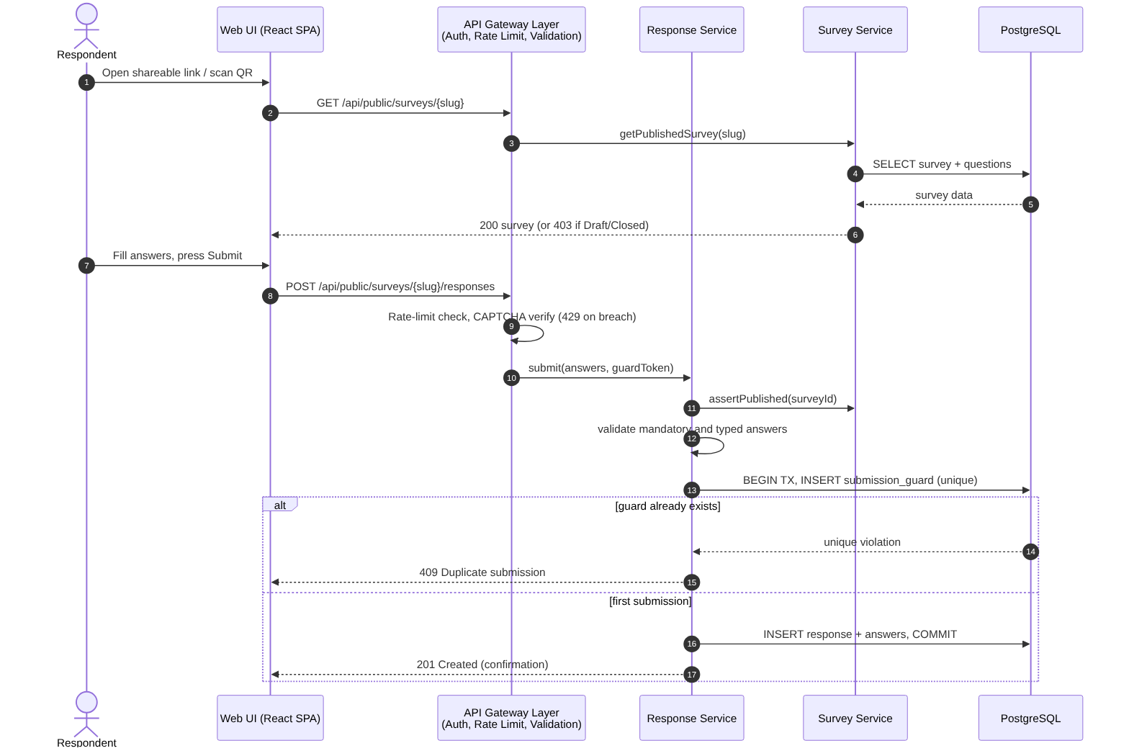
Figure 2: Submit response flow (SVY-F-010, 011, 012, SR-005)

4.2.2 Publishing a survey (link and QR code)
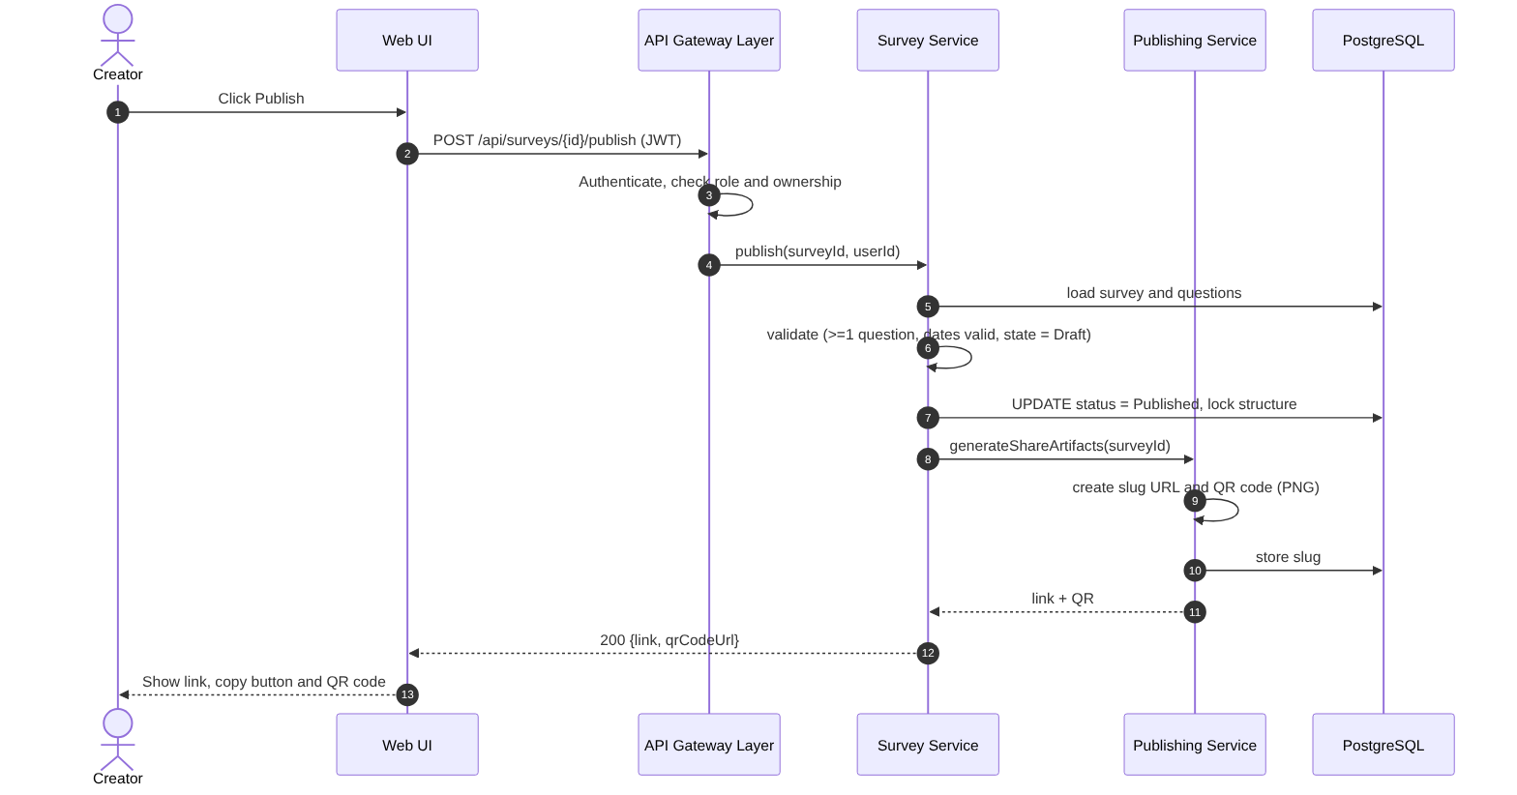
Figure 3: Publish survey flow (SVY-F-008, 009)

4.2.3 Viewing consolidated results and exporting
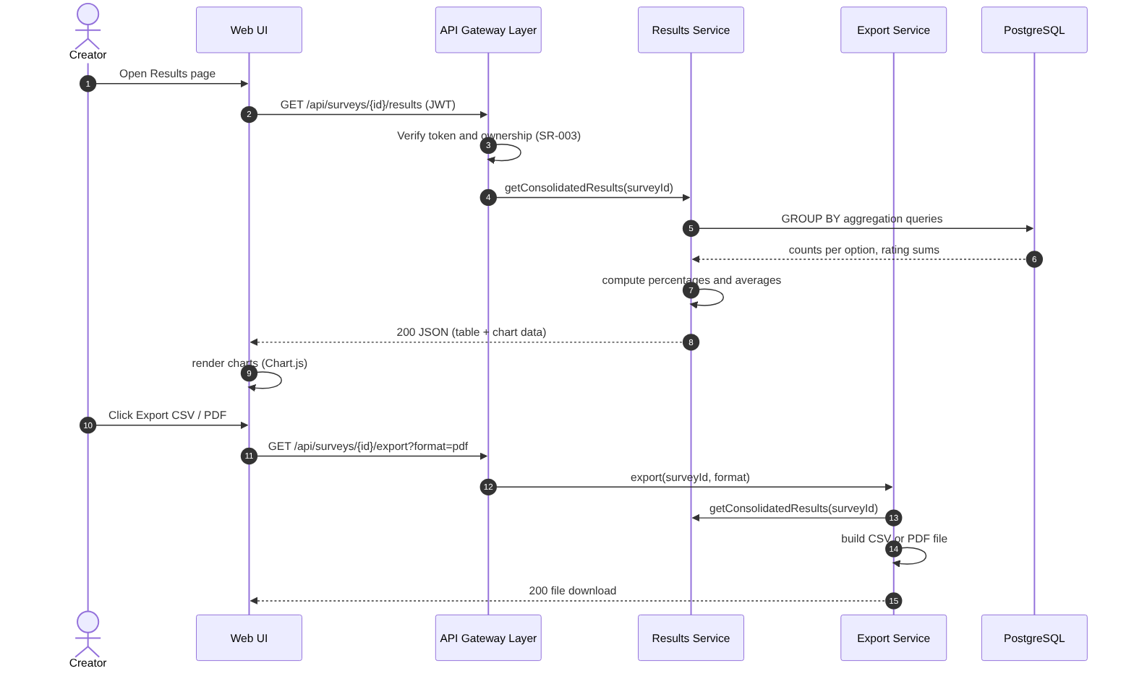
Figure 4: Results and export flow (SVY-F-013, 014, 015, SR-003)

4.3 API Design
Interfaces are defined for three components (REST over HTTPS, JSON, base path /api). Creator endpoints require authentication and ownership checks.

Interface 1: Submit response
Item | Definition
Endpoint | POST /api/public/surveys/{slug}/responses
Request | { answers: [ { questionId, optionIds?: [..], text?: string, rating?: number } ], captchaToken }
Success | 201 { status: "submitted", message }
Errors | 400 validation error (mandatory answer missing, invalid option or rating range); 403 survey not published or closed; 404 unknown slug; 409 duplicate submission; 429 rate limit exceeded
Notes | Duplicate-guard token is set as an HTTP-only cookie when the survey is first opened. Anonymous surveys never store user ID.

Interface 2: Get consolidated results
Item | Definition
Endpoint | GET /api/surveys/{id}/results
Response | { surveyId, totalResponses, questions: [ { id, type, prompt, counts: [{label, count, percent}], average?, textAnswers?: [..] } ] }
Errors | 401 not authenticated; 403 not the owner; 404 survey not found

Interface 3: Publish survey
Item | Definition
Endpoint | POST /api/surveys/{id}/publish
Response | 200 { status: "PUBLISHED", link, qrCodeUrl }
Errors | 401 / 403 authentication or ownership; 409 survey not in Draft; 422 no questions or invalid dates

Standard error format
All errors use { error: { code, message, details? }, requestId }. Messages never reveal internal details, stack traces, or whether an email exists (login and reset return the same generic message).

4.4 Error Handling, Logging and Monitoring
- Error handling: a global exception filter maps domain errors to HTTP codes (400, 401, 403, 404, 409, 422, 429, 500) and the standard error format. Database writes run in transactions and roll back on failure.
- Validation: DTO validation at the boundary (types, lengths, ranges); business validation in services; client-side validation only for convenience.
- Logging: structured JSON logs with request ID, user ID (where logged in), endpoint, status and latency. Passwords, tokens, reset links and answer content are never logged. Security events (failed logins, 429s, access denials, publish/close) are audit-logged.
- Monitoring: uptime monitor on a /health endpoint (supports the 99.5% target), response-time percentiles, error rate, submission failure rate, DB connection pool usage, and alerts on thresholds.
- Resilience: DB connection pool and timeouts; retry with back-off for SMTP; daily backups with tested restore.

4.5 UX Design
- Mobile-first responsive layout from 360 px to 1920 px; tested on Chrome, Firefox, Edge and Safari.
- Survey builder: add question, choose type, toggle mandatory, drag to reorder, live preview; clear Draft/Published/Closed badge; editing controls disabled after publish.
- Survey taker: one clean page, progress indication, inline error next to a missing mandatory question, confirmation page after submit.
- Results page: summary table and chart per question, response count, export buttons.
- Accessibility (WCAG 2.1): keyboard navigation, visible focus, labels and ARIA attributes, sufficient colour contrast, charts accompanied by data tables.
- Consistent, plain-language error and confirmation messages.

4.6 Open Issues and Next Steps
- Conditional questions, partial-progress saving and email invitations (excluded from v1.0) would add a Logic Engine, draft-response storage and a mail-campaign module respectively.
- Evaluate extracting Results/Export as a separate service if report generation becomes heavy.
- Add a read replica and cache layer (Redis) if load testing shows the need.
- Multi-language surveys and social/SSO login are candidates for later releases.

5. Appendices

5.1 Glossary
SMS, SRS, SAD, SPA, REST, JWT, RBAC, ORM, ADR, TLS, STRIDE, CAPTCHA, WCAG: see Section 1.4. Slug: the unique, unguessable text in a survey link. Submission guard: a hashed token recorded to block repeat submissions without identifying the respondent.

5.2 References
- IEEE 42010 (Architecture description)
- SMS SRS v1.0 and SMS Test Plan v1.0
- OWASP Top 10 and OWASP ASVS
- WCAG 2.1
- NIST SP 800-160
- Course material: Lab 3, Component Modelling and Architectural Pattern Selection

5.3 Tools
Mermaid and Graphviz (diagrams, editable sources), draw.io, Swagger/OpenAPI, GitHub Actions, SonarCloud, Postman/Newman, Playwright, k6/JMeter, OWASP ZAP, Mailpit.

